Power Consumption

Arduino MKR1400 and Zero use SAMD21 microcontroller.

SAMD21 sleep mode controller (from controller documentation):

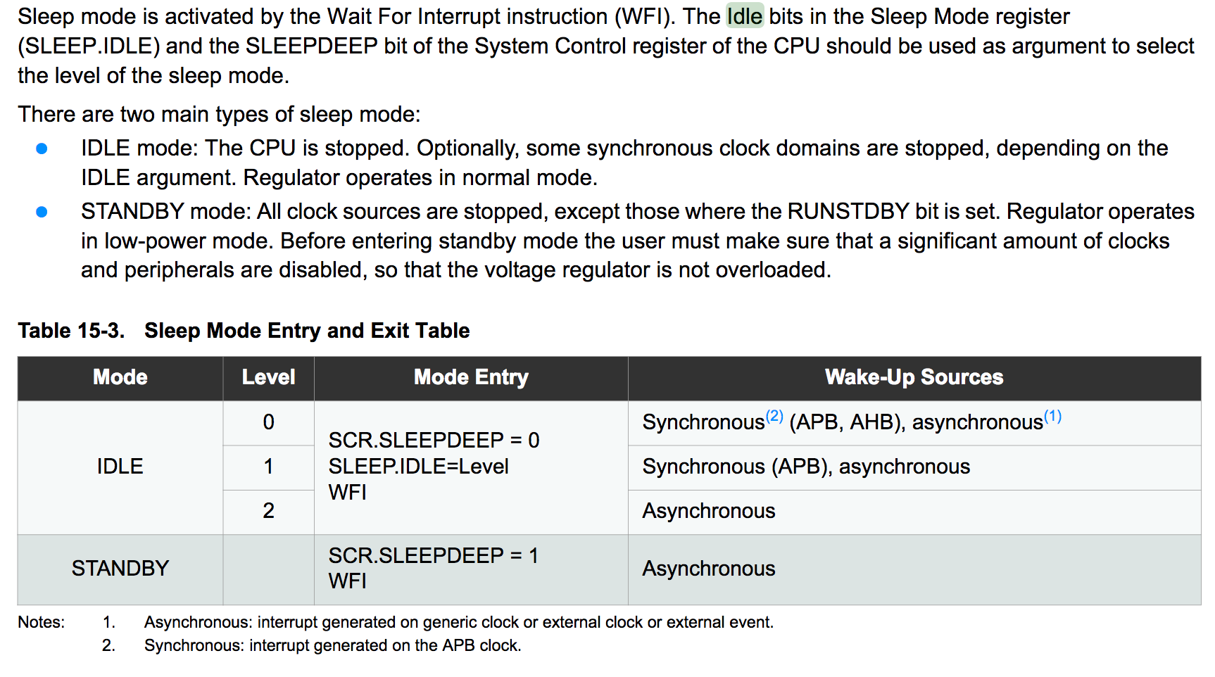

Sleep modes for ATmega328P:

* SLEEP_MODE_IDLE: 15 mA
* SLEEP_MODE_ADC: 6.5 mA
* SLEEP_MODE_PWR_SAVE: 1.62 mA
* SLEEP_MODE_EXT_STANDBY: 1.62 mA
* SLEEP_MODE_STANDBY : 0.84 mA
* SLEEP_MODE_PWR_DOWN : 0.36 mA

My measurements on MKR1400:

* Normal – 25 mA
* LED on - +4 mA
* rtc.standbyMode(); 9 mA
* USB

Links:

[Reducing Power Consumption on Arduino Zero, MKR1000, or any SAMD21 Arduino Part 1](http://forcetronic.blogspot.com/2016/09/reducing-power-consumption-on-arduino_24.html) [SAMD21 core library](https://github.com/arduino/ArduinoCore-samd/blob/master/bootloaders/mzero/Bootloader_D21/src/ASF/sam0/boards/samd21_xplained_pro/samd21_xplained_pro.h)

|  |  |
| --- | --- |
| **Hardware** | |
| **External timer (555?)** | Turns off Arduino completely, and turn it on for sense cycle, relying its clock fully on external timer (such as 555 timer). 555 Timer takes around 3mA at 5 V [(source)](http://www.ti.com/lit/ds/symlink/lm555.pdf) |
| **Cutting off LED** | Should lower current by 4mA |
| Replace Arduino with Microcontroller | Arduino contains a lot of hardware components useless to our use case. Complex and lengthy solution, but should provide huge improvements in battery usage. |
| Reduce clock speed | May produce troubles with RTC. Needs more researching. |
|  |  |
|  |  |
| **Software** | |
| **Variable sleep time** | Sleep Arduino for 5 minutes instead of 1, when temperature is idle. Decrease the sleep to 1 minute, once the cookstove is in use (temperature starts to vary more) |
| **Buffer data** | Buffer data instead of sending it through GSM every time the threshold is reached. Ideally, the GSM module should be launched only once per cookstove use. |
| Idle mode | Run Arduino in idle mode, and using peripheral management enable only modules that are necessary |
|  |  |
|  |  |